# Instructions to Setup Cloudera VM

1. Install VirtualBox
2. Download Cloudera Quick start VM for virtual Box

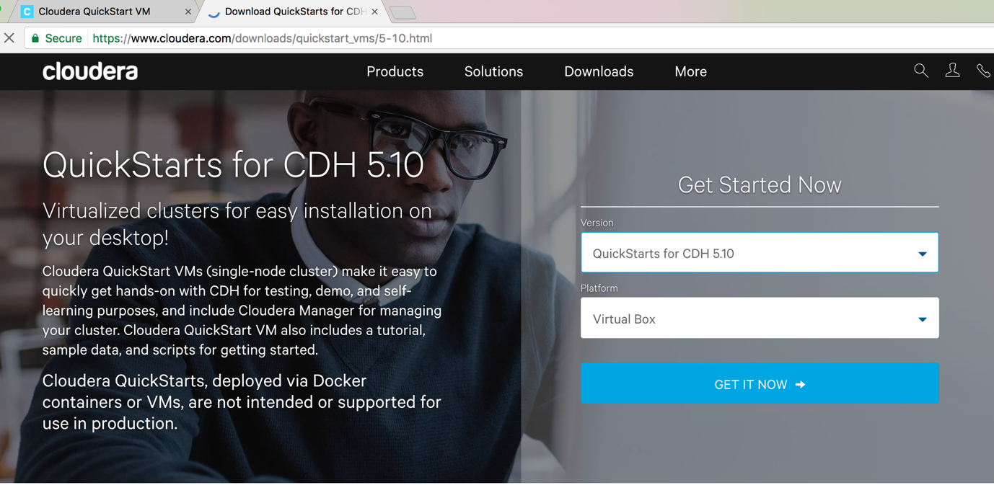

1. Extract the downloaded cloudera vm zip
2. Open the ovf file 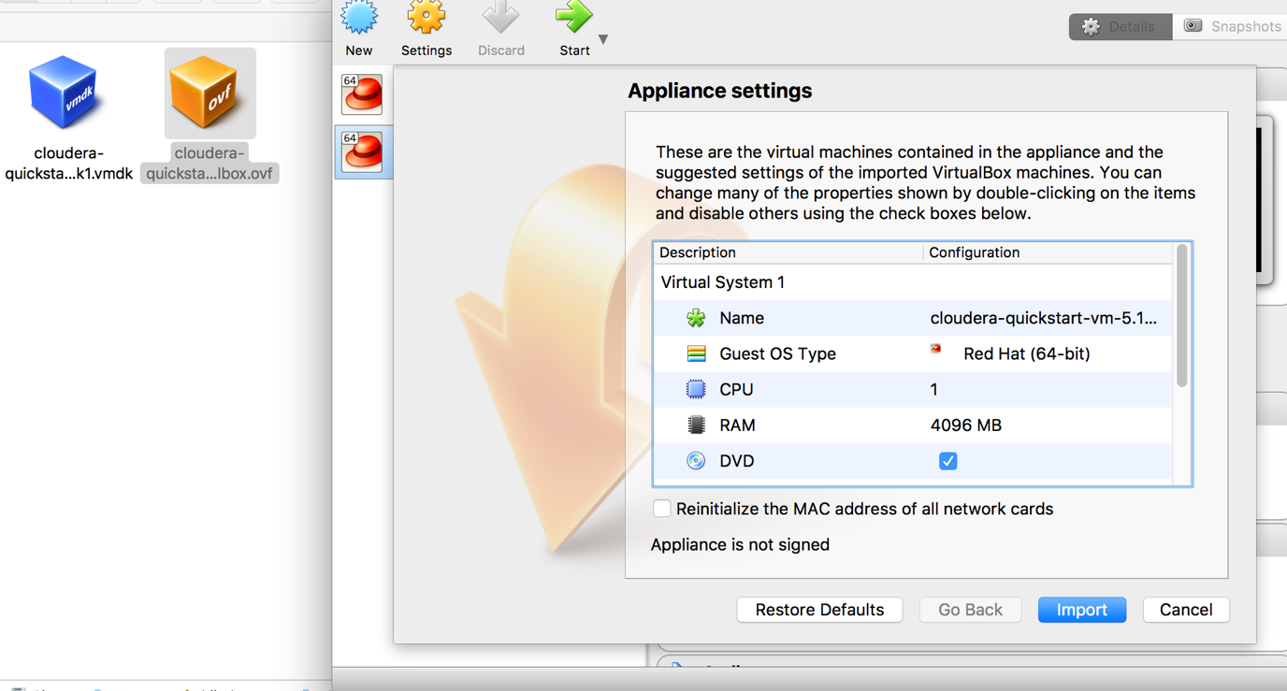
3. Import

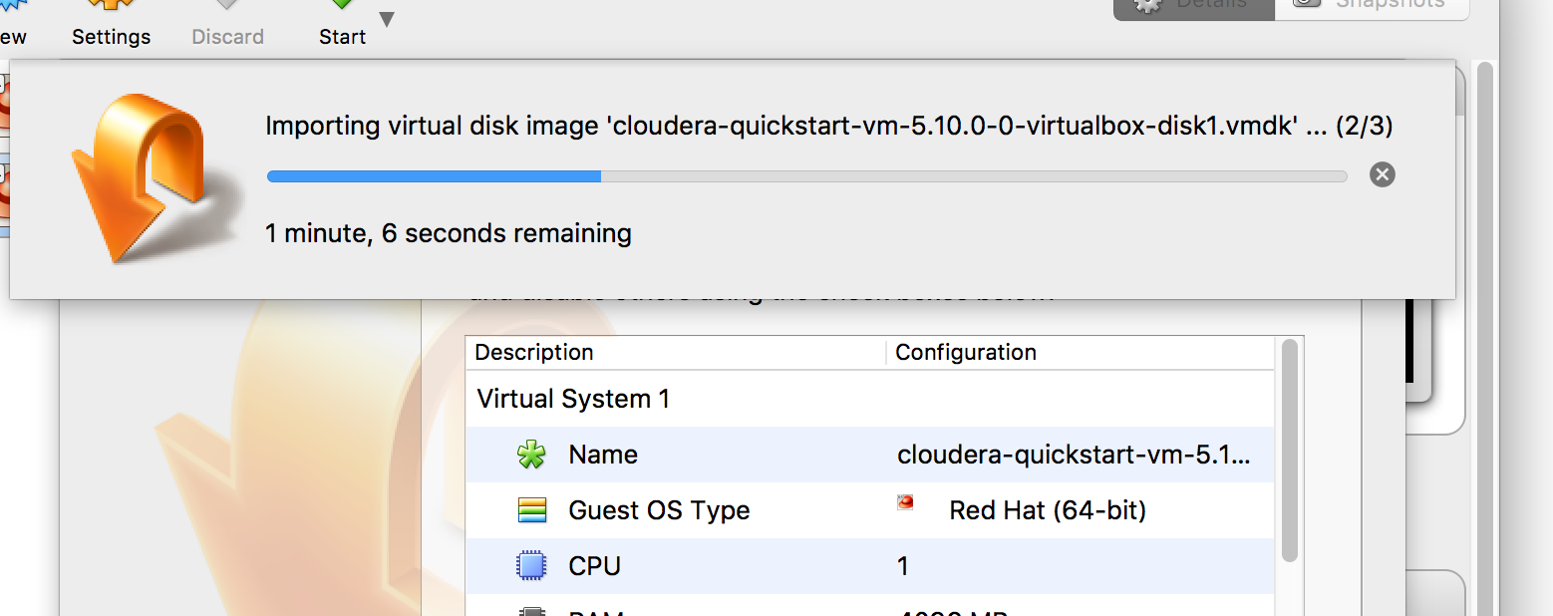

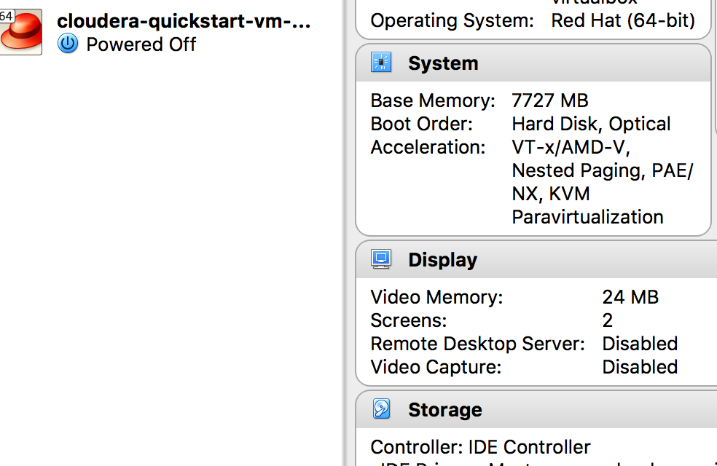

1. Open cloudera-quickstart-vm